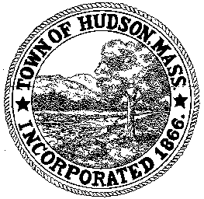

BOARD OF HEALTH
78 Main Street
Hudson, MA 01749
(978) 562-2020
Meeting Agenda
July 24, 2012
7:00 PM

- Preliminaries
1.1 Open Meeting
1.2 Roll Call

2.0 Public Hearing
2.1 89 Broad Street

3.0 Review Installer Application
3.1 Ernie’s Excavating Inc.

4.0 Review Septic Plan
4.1 175 White Pond Road

5.0 General Business
5.1 NACCHO Conference
5.2 Voucher BOH 072412 - $2755
5.3 Voucher BOH 072012 - $578
5.4 Voucher BOH 073012 - $63,593.89
5.4 Minutes June 26, 2012

6.0 Correspondence

7.0 Adjournment

Next Meeting: August 14, 2012

